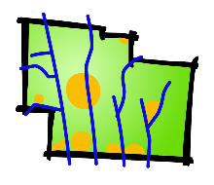 | Combination of Platted Lots  Delaware County, Ohio  (for unincorporated areas only) | RPC Number  ___________________  Sec. _______ Ph. _______ Pt. _____

SUBDIVISION NAME |  | (circle one) Residential Commercial
TOWNSHIP

APPLICANT/  CONTACT | Name | Phone
 | Address | E-mail
 | City, State, Zip

PROPERTY OWNER | Name | Phone
 | Address | E-mail
 | City, State, Zip

SURVEYOR/  ENGINEER | Name | Phone
 | Address | E-mail
 | City, State, Zip

PARCEL
NUMBERS

SUBMISSION  REQUIREMENTS |  | Mylar Plat of the land as reconfigured with signature of Landowner, Surveyor, and Township Zoning Officer (size 22" x 34"). Include signature lines for Health (if applicable), County Engineer, Sanitary Engineer, Regional Planning, County Auditor, and County Recorder.
 |  | Fee - $500

__________________________________________________________
Owner (or agent for owner) and Date

Delaware County Regional Planning Commission, 1610 State Route 521, P.O. Box 8006
Delaware, OH 43015 (740) 833-2260

Effective 01/01/24

