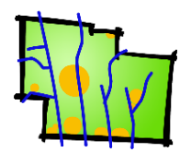 | Delaware County Regional Planning Commission  GIS Map Print Order Form  Please do not send payment with an order without calling first.

Customer Name |  |  |  | Date
Address
Telephone |  | E-mail

Description and/or custom layers (see below) | Size | Color/BW | No. of Copies
 | % 8 ½ x 11 % 11 x 17  % 24 x 36 % _________ | % Color % B&W
 | % 8 ½ x 11 % 11 x 17  % 24 x 36 % _________ | % Color % B&W
 | % 8 ½ x 11 % 11 x 17  % 24 x 36 % _________ | % Color % B&W

Common layers | General: Aerial photo, Parcels, Roads, Twp and Muni Boundaries, School Districts, Zip Codes, any other data shown on the Auditor’s website.  Environmental: Contours (topography), Soils, Floodplains, Streams.  Utilities: Sewer Lines, Del-Co Water Lines, Major Gaslines.  RPC-managed: Proposed subdivisions, Subdivision proposed roads, Local proposed roads, Sidewalks and wider paths, Historical Features, Zoning, etc.

 | Non-RPC Members | RPC Member Communities | ____________________________________  Sign and Date
8½"x 11" | b/w: $0.10 / color: $1.00 | b/w: $0.10 / color: $0.40
11" x 17" | b/w: $0.10 / color: $2.00 | b/w $0.10 / color: $1.00
24" x 36" | $15.00* | $5.00*
36" x 48" | $25.00* | $10.00*
* Annual Zoning and Comp Plan maps provided for communities at no cost. Large prints including aerial photography may be subject to an additional $5.00. Charges are based on material costs.
Custom maps may include staff time – call for info.

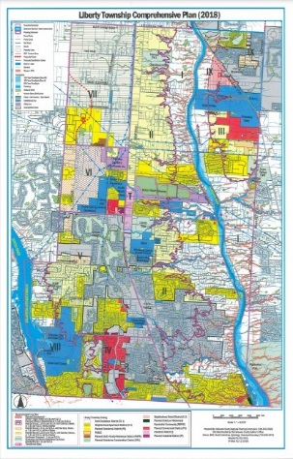
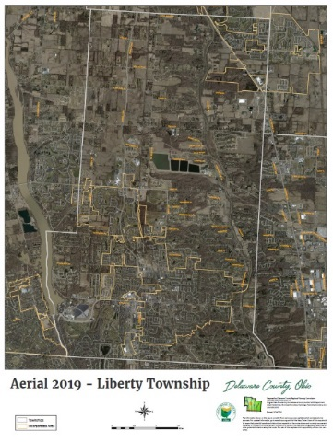
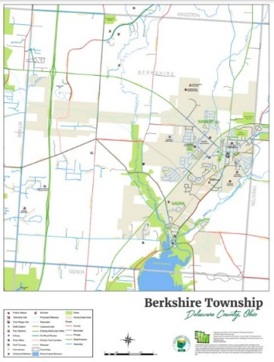
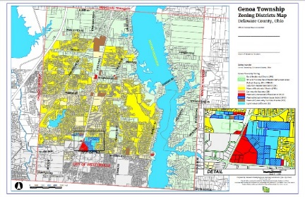

Sample maps, l to r: Community Map, Aerial Photo, Comprehensive Plan, Zoning Map.

Delaware County Regional Planning Commission, 1610 State Route 521, P.O. Box 8006
Delaware, OH 43015 (740) 833-2260
Effective 9/1/23

