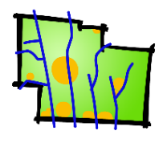 | Delaware County Regional Planning Commission  GIS Print Order Form

Customer Name |  |  |  | Date
Address
Telephone |  | E-mail

Description and/or custom layers (see below) | Size | Color/BW | No. of Copies
 | % 8 ½ x 11 % 11 x 17  % 24 x 36 % _________ | % Color % B&W
 | % 8 ½ x 11 % 11 x 17  % 24 x 36 % _________ | % Color % B&W
 | % 8 ½ x 11 % 11 x 17  % 24 x 36 % _________ | % Color % B&W

Common layers | Typical: Aerial, Parcels, Roads, Twp and Muni Boundaries, School Districts, Zip Codes, any other data shown on the Auditor’s website.  Environmental: Contours, Soils, Floodplains, Streams.  Utilities: Sewer Lines, Del-Co Water Lines, Major Gasline.  RPC-managed: Proposed subdivisions, Subdivision proposed roads, Local proposed roads, Sidewalks and wider paths, Historical Features, etc.

 | Non-RPC Members | Members | ____________________________________  Sign and Date
8½"x 11" | b/w: $0.10 / color: $1.00 | b/w: $0.10 / color: $0.40
11" x 17" | b/w: $0.10 / color: $2.00 | b/w $0.10 / color: $1.00
24" x 36" | $15.00* | $5.00*
36" x 48" | $25.00* | $10.00*
* Large prints including aerial photography are subject to an additional $5.00. Charges are based on material costs.
Custom maps may include staff time – call for info.

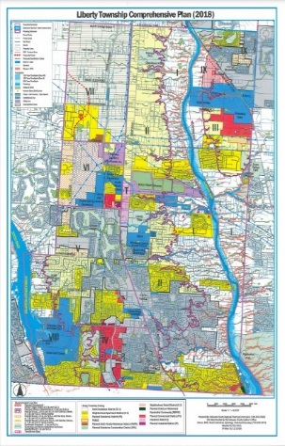
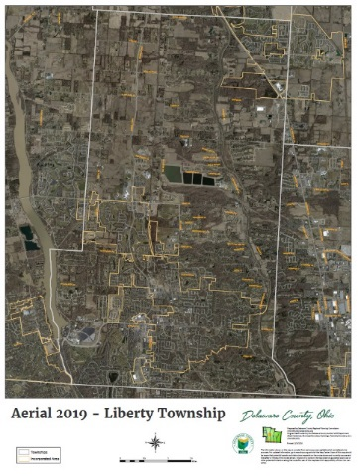
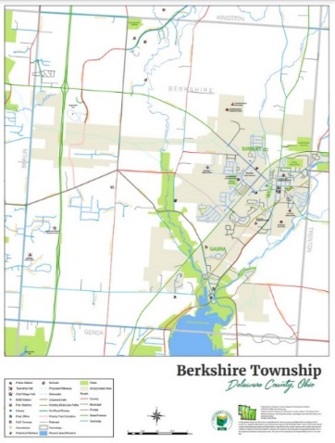
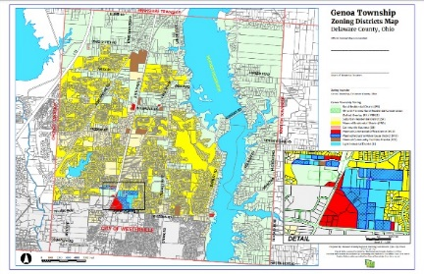

Sample maps, l to r: Community Map, Aerial Photo, Comprehensive Plan, Zoning Map.

Delaware County Regional Planning Commission, 109 N. Sandusky Street, Delaware, OH 43015 (740) 833-2260
Effective 08/01/20

