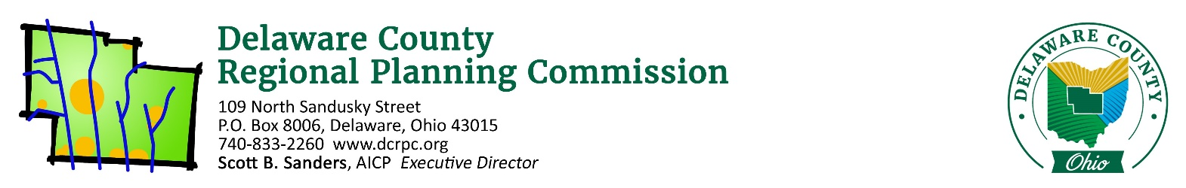
October 13, 2020

ATTN: EDB International, Inc. (achevalier@edbintl.com)

Re: Porshi – Orange Township – 20 Lots / 9.68 Acres

EDB International,

On Thursday, October 15th, 2020 the Regional Planning Commission staff conducted a sketch plan/site review of the above referenced site. Following is a list of areas reviewed. These comments should be addressed if you intend to submit a Preliminary Plan application.

Does the proposal appear to conform to the local zoning code/development plan?
No. Orange Township approved the rezoning to be 19 dwelling units with an additional lot for a clubhouse. The submitted proposal shows 20 dwelling units and an additional lot for the clubhouse.

One lot needs to be removed, or the rezoning needs amended to permit an additional lot to be in conformance with the Zoning Resolution.

Does the proposed development conform to the local comprehensive plan?
No. The Orange Township Comprehensive Plan calls for large lot development for lands fronting onto Orange Road and South Old State Road. The property, having already been rezoned to planned development, may be an exception to this recommendation.

Are there any known archeological, historical or natural resources on this site that could affect this development?
The pond on the property is a hindrance to planned development of this type, but it’s been incorporated into the plan. Ensure during engineering phases that the pond design is capable of handling the extra runoff from developing the property as residential that’s more dense than large lots.

There is also a grouping of trees in the southeast corner of the property. Some of these will need ot be removed, but try and preserve the trees along Orange road and South Old State Road to the greatest extent possible.

Are there opportunities for vehicular/pedestrian/open space connections to adjacent lands?
No, all surrounding properties which could gain potential access are already developed.

Is the road configuration and lot layout appropriate for the site?
The presented layout is the most logical in terms of maximizing the density and road frontage, while simultaneously limiting the number of curb cuts to one.

(If a Common Access Driveway is proposed) Is this an appropriate use of a Common Access Driveway?
N/A

Does the proposed development advance the local health, safety and welfare?
As long as the existing pond and/or future pond design is capable of handling the extra stormwater runoff, then yes, the development advances the local health, safety, and welfare by providing additional housing to the capacity of the property.

Other comments:
None.

Please see the attached reports from other agencies and note the following quote from Section 101.06 of the DCRPC Subdivision Regulations: “Coordination and Compatibility. The subdivider is responsible to ensure proposals comply with applicable federal, state, Commission, county, township, and district regulations policies and practices involving subdivision, health, environment, floodplain, storm water, wetland, erosion and sedimentation control, zoning, access management, or other issues.”

If you wish to proceed with the subdivision, you will need to work closely with the Delaware General Health District if applicable (740-368-1700), and the Soil and Water Conservation District (740-368-1921). The County Engineer’s office (740-833-2400) should be consulted directly for road design specifications. If you have any other questions regarding the subdivision procedures, feel free to contact our office.

Sincerely,

Jonathan P. Miller, AICP, GISP
jpmiller@co.delaware.oh.us
(740) 833 - 2263

