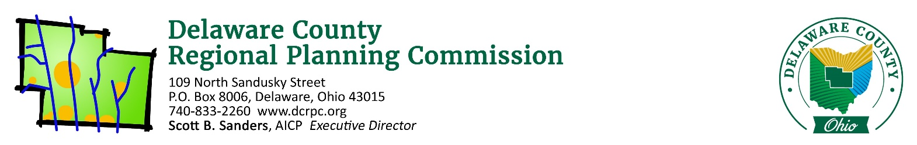
October 13, 2020

ATTN: Michelle Brown (mbrow56@icloud.com)

Re: Brown Common Access Subdivision – Liberty Township – 3 or 4 Lots / 5.292 Acres

Ms. Brown,

On Thursday, October 15th, 2020 the Regional Planning Commission staff conducted a sketch plan/site review of the above referenced site. Following is a list of areas reviewed. These comments should be addressed if you intend to submit a Preliminary Plan application.

Does the proposal appear to conform to the local zoning code/development plan?
The proposed plan looks like it could conform to Liberty Township’s Zoning Resolution regarding minimum lot size and frontage requirements. No measurements were given. When deciding on the final layout of the lots, each lot will need to be a minimum of 1 acre, with 150 feet of frontage onto the CAD or public roadway if the lots are under 2 acres.

Does the proposed development conform to the local comprehensive plan?
Yes. The Liberty Township Comprehensive Plan identifies this area as a transitional zone within Subarea II. The recommendations for this Subarea include residential uses with a maximum density of 1.25 units per net developable acre, which fits well with the 1 acre minimum lot size in the FR-1 zoning.

Are there any known archeological, historical or natural resources on this site that could affect this development?
The pond on the property will need to be developed around. Make sure, during engineering phases, that the pond will be capable of handling the additional water runoff from two additional housing structures and the associated drive.

There are also minor treelines along the railroad and north and south property lines near Old Liberty Road which should be preserved to the greatest extent possible.

Are there opportunities for vehicular/pedestrian/open space connections to adjacent lands?
No, all surrounding properties which could gain potential access are already developed.

Is the road configuration and lot layout appropriate for the site?
Both of the presented lot layouts are appropriate for the site. Layout #1 provides a more equitable burden of bordering the railroad, and would be preferred to Layout #2.

(If a Common Access Driveway is proposed) Is this an appropriate use of a Common Access Driveway?
This is an appropriate use for a CAD. The surrounding properties can not be further developed, and the subject property is oddly shaped. In order to create additional building lots, a CAD is the only option.

Does the proposed development advance the local health, safety and welfare?
In so much as additional lots would be created, yes.

Other comments:
None.

Please see the attached reports from other agencies and note the following quote from Section 101.06 of the DCRPC Subdivision Regulations: “Coordination and Compatibility. The subdivider is responsible to ensure proposals comply with applicable federal, state, Commission, county, township, and district regulations policies and practices involving subdivision, health, environment, floodplain, storm water, wetland, erosion and sedimentation control, zoning, access management, or other issues.”

If you wish to proceed with the subdivision, you will need to work closely with the Delaware General Health District if applicable (740-368-1700), and the Soil and Water Conservation District (740-368-1921). The County Engineer’s office (740-833-2400) should be consulted directly for road design specifications. If you have any other questions regarding the subdivision procedures, feel free to contact our office.

Sincerely,
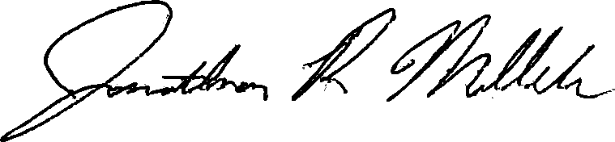

Jonathan P. Miller, AICP, GISP
jpmiller@co.delaware.oh.us
(740) 833 - 2263

