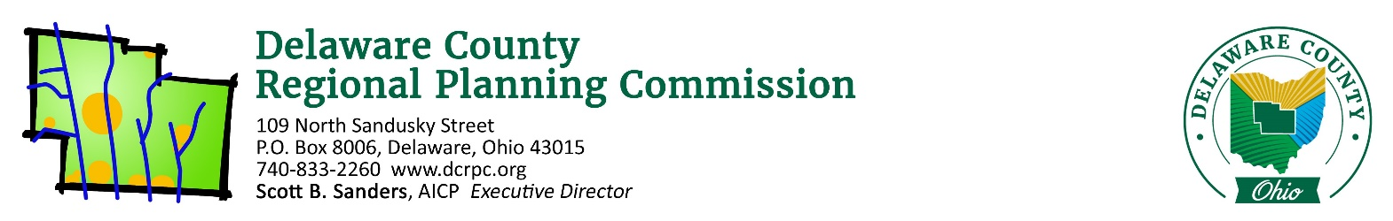
October 13, 2020

ATTN: 365LAND c/o Matt Dickens (matt@365-land.com)

Re: 4 Lot CAD (7300 Concord Road) – Concord Township & Millcreek Township (Union County) 4 Lots / 12.151 Acres

Mr. Dickens,

On Thursday, October 15th, 2020 the Regional Planning Commission staff conducted a sketch plan/site review of the above referenced site. Following is a list of areas reviewed. These comments should be addressed if you intend to submit a Preliminary Plan application.

Does the proposal appear to conform to the local zoning code/development plan?
The proposed plan does conform to Concord Township’s Zoning Resolution regarding minimum lot size and frontage requirements.

Because part of Lot 4 is within Millcreek Township in Union County and accessed through Delaware County, you will need to communicate with them directly regarding the applicability of their zoning code. They will also likely need to sign any final approvals or plats, and may even require a separate approval process since the property is ultimately being platted.

Does the proposed development conform to the local comprehensive plan?
Yes. The property is in the Concord Township Comprehensive Plan’s Subarea III, and recommends residential uses at a minimum lot size of 1.5 acres. It also recommends potential new roads and some mixed-uses that aren’t applicable to this section of the Subarea.

Are there any known archeological, historical or natural resources on this site that could affect this development?
Nothing that would prevent development. Treelines exist along the north and south property lines, and these should be preserved to the greatest extent possible.

Are there opportunities for vehicular/pedestrian/open space connections to adjacent lands?
Yes, the properties to the north (33 acres in Delaware County), south (21 acres in Delaware County), and west (Union County) are all agricultural properties. The properties on the east side of Concord Road have also been rezoned (parts still pending final approval) to accommodate a development plan for 740 single-family homes.

Is the road configuration and lot layout appropriate for the site?
If a CAD is deemed to be an appropriate use of the property, then yes, the layout is appropriate given the site’s geometry.

(If a Common Access Driveway is proposed) Is this an appropriate use of a Common Access Driveway?
Potentially not. With Concord Highlands (740 homes) potentially building on the opposing side of Concord Road, and the agricultural nature of the surrounding properties on this property’s side of Concord Road – reservation of the acreage to ensure a more unified development may be in the best interest.

CADs are intended for odd-shaped parcels or parcels with limited development potential, neither of which may apply in this scenario.

Does the proposed development advance the local health, safety and welfare?
In so much as additional lots would be created, yes.

Though, a proposal which unified the vacant properties would provide more housing and opportunities for common open space areas.

Other comments:
Have any discussion been had with the surround property owners regarding their future intentions with the properties. This section of both Millcreek Township and Concord Township are experiencing development pressures, and unifying the properties may be advantageous from a development perspective.

Please see the attached reports from other agencies and note the following quote from Section 101.06 of the DCRPC Subdivision Regulations: “Coordination and Compatibility. The subdivider is responsible to ensure proposals comply with applicable federal, state, Commission, county, township, and district regulations policies and practices involving subdivision, health, environment, floodplain, storm water, wetland, erosion and sedimentation control, zoning, access management, or other issues.”

If you wish to proceed with the subdivision, you will need to work closely with the Delaware General Health District if applicable (740-368-1700), and the Soil and Water Conservation District (740-368-1921). The County Engineer’s office (740-833-2400) should be consulted directly for road design specifications. If you have any other questions regarding the subdivision procedures, feel free to contact our office.

Sincerely,
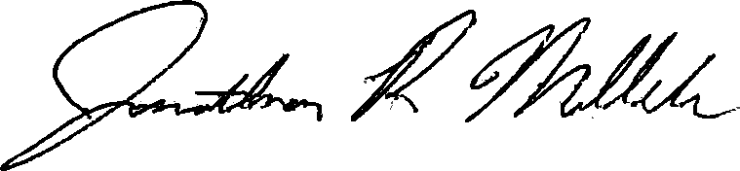

Jonathan P. Miller, AICP, GISP
jpmiller@co.delaware.oh.us
(740) 833 - 2263

