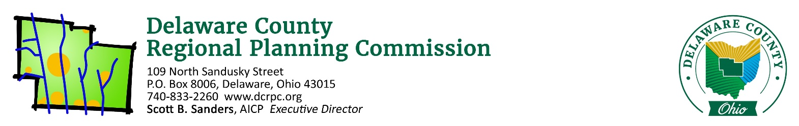
October 13, 2020

ATTN: Plan 4 Land c/o Joe Clase (joe@plan4land.net)

Re: JES Development CAD – Brown Township – 4 Lots / 12.151 Acres

Mr. Clase,

On Thursday, October 15th, 2020 the Regional Planning Commission staff conducted a sketch plan/site review of the above referenced site. Following is a list of areas reviewed. These comments should be addressed if you intend to submit a Preliminary Plan application.

Does the proposal appear to conform to the local zoning code/development plan?
The proposed plan does not completely conform to Brown Township’s Zoning Resolution, and subsequently the proposal does not completely conform to Delaware County Subdivision Regulations either.

Lot 1 and Lot 4 do not have the minimum required road frontage to be considered a free-standing lot for the purposes of obtaining the two additional lots. As such, the lots will either need to be reconfigured to obtain the required frontage, a variance for road frontage will be needed, or a variance from the Delaware County Regional Planning Commission to increase the number of permitted lots from 3 to 4 will be needed.

Does the proposed development conform to the local comprehensive plan?
No. This property is located in Sub Area 4 of Brown Township, the Critical Resource area. This area specifies a maximum density of 1 unit per 5 acres. Additionally, the Comprehensive Plan recommends a no build buffer of 120 feet from all streams (one is located on the property), and encourages conservation designs to preserve trees and wooded areas, as opposed to the large lot layout that’s presented.

However, the proposal as a CAD does conform with the recommendation to limit curb cuts along Hogback Road.

Are there any known archeological, historical or natural resources on this site that could affect this development?
Yes, the site is predominantly wooded with a drainage course and associated slopes along the northern edge of the property.

Are there opportunities for vehicular/pedestrian/open space connections to adjacent lands?
No, all of the surrounding land is already developed as large lot residential properties.

Is the road configuration and lot layout appropriate for the site?
Though the proposal is not in conformance with Brown Township Zoning or Delaware County Regional Planning Commission Regulations, the layout of the CAD is generally appropriate. Some configuration modifications are needed to conform the applicable regulations though.

(If a Common Access Driveway is proposed) Is this an appropriate use of a Common Access Driveway?
Based on the lack of nearby developable properties, yes.

Does the proposed development advance the local health, safety and welfare?
While the proposal does provide additional lots, it also proposes development in an environmentally sensitive area. Discretion will be needed to ensure that the development minimizes all environmental impacts in order to promote a net gain for the local health, safety, and welfare.

Other comments:
Consider utilizing a layout which groups housing on smaller lots, closer to Hogback Road, in order to preserve as much of the wooded areas as possible. Also try to maintain, at a minimum, a small strip of the existing treeline to preserve the character of Hogback Road.

Please see the attached reports from other agencies and note the following quote from Section 101.06 of the DCRPC Subdivision Regulations: “Coordination and Compatibility. The subdivider is responsible to ensure proposals comply with applicable federal, state, Commission, county, township, and district regulations policies and practices involving subdivision, health, environment, floodplain, storm water, wetland, erosion and sedimentation control, zoning, access management, or other issues.”

If you wish to proceed with the subdivision, you will need to work closely with the Delaware General Health District if applicable (740-368-1700), and the Soil and Water Conservation District (740-368-1921). The County Engineer’s office (740-833-2400) should be consulted directly for road design specifications. If you have any other questions regarding the subdivision procedures, feel free to contact our office.

Sincerely,
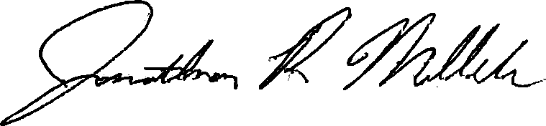

Jonathan P. Miller, AICP, GISP
jpmiller@co.delaware.oh.us
(740) 833 - 2263

