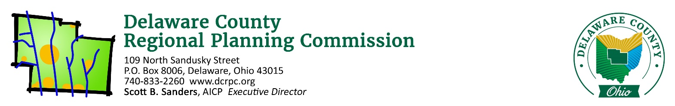
October 13, 2020

ATTN: Scioto Land Surveying c/o Karen Coffman (karen@sciotolandsurveying.com)

Re: Keller Subdivision Lot 294 Division 1 – Berlin Township – 2 Lots / 2.767 Acres

Ms. Coffman,

On Thursday, October 15th, 2020 the Regional Planning Commission staff conducted a sketch plan/site review of the above referenced site. Following is a list of areas reviewed. These comments should be addressed if you intend to submit a Preliminary Plan application.

Does the proposal appear to conform to the local zoning code/development plan?
The proposed plan does conform to Berlin Township’s Zoning Resolution regarding minimum lot size and frontage. When planning the lot layout, ensure that the applicable regulations regarding setbacks, accessory structures, and driveways are met, in addition to any other regulations that may be required by Berlin Township.

Does the proposed development conform to the local comprehensive plan?
Yes. The comprehensive plan shows this property in Planning Area Six. The recommendations for this planning area include residential uses with a density of one unit per net developable acre for properties east of Africa Road.

Are there any known archeological, historical or natural resources on this site that could affect this development?
Yes. Be cognizant of the drainage course – and associated slopes – which runs along the rear of the property.

Are there opportunities for vehicular/pedestrian/open space connections to adjacent lands?
No, all of the surrounding properties are either developed or part of the park system for Alum Creek Reservoir.

Is the road configuration and lot layout appropriate for the site?
While there is no proposed roads, the orientation of the split is logical and appropriate by dividing the lot in two similarly sized lots which mirror the lot widths of the other residential properties on Sherman Road.

(If a Common Access Driveway is proposed) Is this an appropriate use of a Common Access Driveway?
N/A.

Does the proposed development advance the local health, safety and welfare?
Yes, the proposal provides an additional lot in conformance with the Comprehensive Plans.

Other comments:
None.

Please see the attached reports from other agencies and note the following quote from Section 101.06 of the DCRPC Subdivision Regulations: “Coordination and Compatibility. The subdivider is responsible to ensure proposals comply with applicable federal, state, Commission, county, township, and district regulations policies and practices involving subdivision, health, environment, floodplain, storm water, wetland, erosion and sedimentation control, zoning, access management, or other issues.”

If you wish to proceed with the subdivision, you will need to work closely with the Delaware General Health District if applicable (740-368-1700), and the Soil and Water Conservation District (740-368-1921). The County Engineer’s office (740-833-2400) should be consulted directly for road design specifications. If you have any other questions regarding the subdivision procedures, feel free to contact our office.

Sincerely,
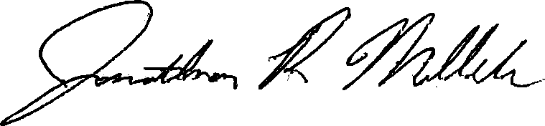

Jonathan P. Miller, AICP, GISP
jpmiller@co.delaware.oh.us
(740) 833 - 2263

