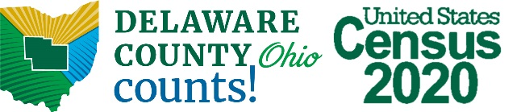

Local government officials play a crucial role in raising awareness of the 2020 Census. As local government officials, YOU can reach communities and populations who might otherwise be unaware of the broader awareness campaign of the US Census Bureau. In fact, some young adults may not even remember the last Census in 2010!
This census will be the first to be completed mainly online. For those in rural areas, those without computer skills or perhaps those of an older generation, this may create confusion or an obstacle for reaching an accurate count.
And those populations could truly benefit from an accurate count.
Why? Census counts affect funding in many different categories, since the results of the census are used as a resource for the next ten years. In fact, according to the US Census Bureau, census results are supposed to disperse more than $675 billion in federal funds, grants and support.
BASICS:
- 95 percent of households will receive an invitation to participate in the census by regular mail;
- Every household will have the option of responding online, by mail or by phone;
- Remaining households may receive their paperwork when it is dropped off by a census taker;
- Less than 1 percent will be counted in person by a census taker.
REMEMBER:
- The Census is 100 percent confidential;
- The U.S. Census Bureau will NEVER ask for your Social Security number or bank information, and they will not ask for money;
- Public libraries have computers that can be used for many purposes, including completing the census, and librarians are will and able to help those who may need a hand.
WHAT DOES THE CENSUS AFFECT?
Census information will affect many aspects of Ohioans’ lives. It will impact maps drawn for broadband expansion purposes. It could change Ohio’s Congressional representation. (Ohio may lose a Congressional seat if population trends continue). It will also affect Ohio’s redistricting process, which means your state House or Senate district may change.
The Delaware County Regional Planning Commission has a number of resources available on its website at: regionalplanning.co.delaware.oh.us/data/census/

